Electrolysis of ionic compounds
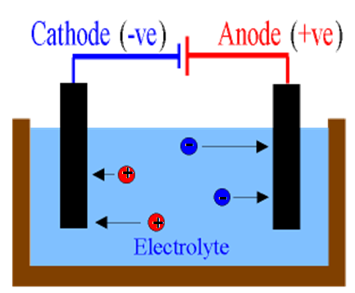
Electrolysis is the breaking down or ‘decomposition’ of a substance using electricity. Ionic substances contain positive ions (cations) and negative ions (anions) . The ionic substance is melted or dissolved in solution to set the ions ‘free’ to move. The substance being decomposed is called the electrolyte. In electrolysis the electric current enters and leaves the electrolyte by conducting rods called electrodes. The positive electrode is called the anode and the negative electrode is called the cathode. In electrolysis the negative ions move towards the anode. When they get there they lose electrons to form neutral atoms. The positive ions move towards the cathode. When they get there they gain electrons to form neutral atoms.

Challenge: Using the information above to help you match up each keyword to its definition.
